Задание: 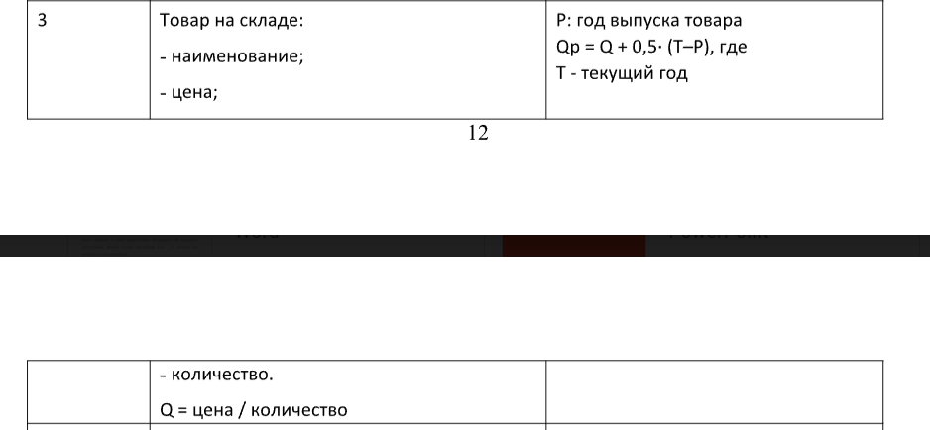

Входные и выходные данные:

Блок-схема

Листинг программы:

interface QualityEvaluator {  
 fun calculateQuality(): Double  
}

abstract class WarehouseItem(  
 val name: String,  
 val price: Double,  
 val quantity: Int) : QualityEvaluator{  
 constructor(name: String, price: Double, quantity: Int, year: Int) : this(name, price, quantity)  
  
 override fun calculateQuality(): Double{  
 return 5.0  
 }  
 open fun printInfo() {  
 *println*("Warehouse Item: $name")  
 *println*("Price: $price")  
 *println*("Quantity: $quantity")  
 *println*("Quality: ${calculateQuality()}")  
 }  
}  
  
  
class SubWarehouseItem(  
 name: String,  
 price: Double,  
 quantity: Int,  
 val year: Int  
) : WarehouseItem(name, price, quantity) {  
  
 override fun calculateQuality(): Double {  
 val baseQuality = price / quantity  
 return baseQuality + 0.5 \* (getCurrentYear() - year)  
 }  
  
 private fun getCurrentYear(): Int {  
 return 2024  
 }  
  
 override fun printInfo() {  
 super.printInfo()  
 *println*("Year of Production: $year")  
 *println*("Quality for SubWarehouseItem: ${calculateQuality()}")  
 }  
}

fun main() {  
 val subWarehouseItem = SubWarehouseItem("Item B", 150.0, 5, 2020)  
 subWarehouseItem.printInfo()  
}